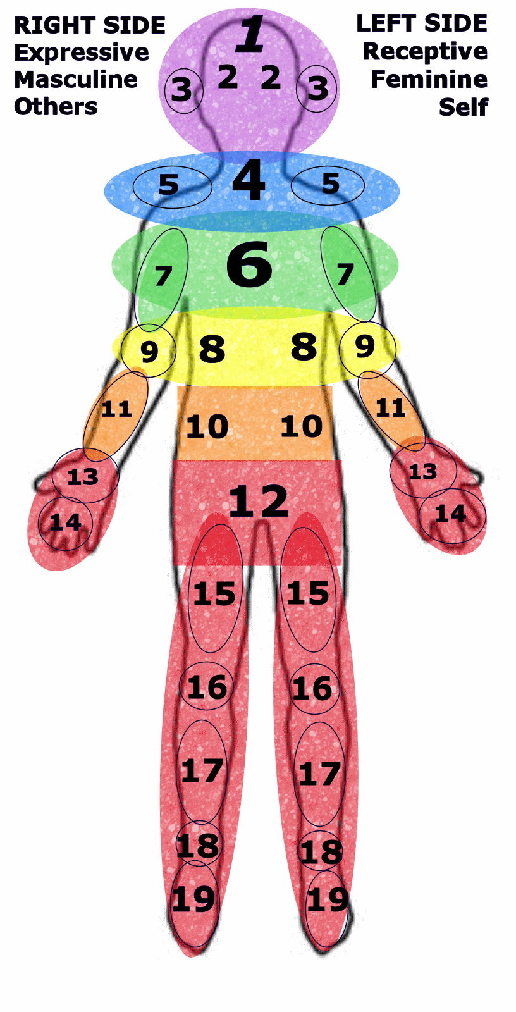
A 12 Hr
CE Course!
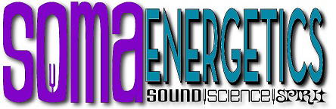
Phase 2 Vibrational Sound Course
Including 5th Dimensional Energy Techniques
In This Course You Will Learn:  - Energy Scanning Technique – Body Mapping (Corner Figure)  - Introduction of SomaEnergetics Solfeggio Body Tuners  - Chakra Stone Relaxation Technique  - Using Body Tuners on Acupressure Points  - Opening the Eye of Enlightenment: see through illusion  - Clearing the Heart Center for co-creative relationships  The Energy Scanning Technique  - Provides a way to scan the body and retrieve information from the bio-feedback system  - Use Body Mapping to identify emotional energetic blockages  - Allows the client the opportunity to clear blockages by releasing what they are ready to release ~ restoring energetic balance and flow.  Participants in this course will learn and be able to demonstrate a set of protocols for using the Solfeggio tuning forks that can be utilized with most any other modality to assist them in helping clients accomplish their intention for health and wellness. These protocols may be utilized as a stand-alone modality, in addition to massage or other therapies. | When:  TBD  Friday & Saturday 9-4 each day  Where:  1000 Willagillespie Rd. Eugene  Massage Therapy CE Hours  Course approved for 12 CE Hours:  NCBTMB Approved Provider 450637-08  Certification Program also available.  Fees: Course Only:  $299  Optional Course Materials:  Body Tuner Kit: $299  Crystal Tuner: $30  Om Tuner $50  Chakra Stones $20 (approx)  Prerequisite:  Completion of Phase 1 Course live or DVD
Instructor, Jan Konow, CVSMT, is a Certified Vibrational Sound Master Teacher and has been in the field of Sound Techniques for seven years. As a CVSMT through the Natural Therapies Certification Board, she facilitates classes and workshops in Sound Techniques as well as offering Reiki, Essential Oil Drop and Specialized Sound Technique sessions to her clients. Jan’s compassion and intention for healing along with the ancient Solfeggio frequencies that energetically trigger the body to respond, release, reset and repair have given hope to those that had none. We invite you to come and experience the power of Sound Healing!

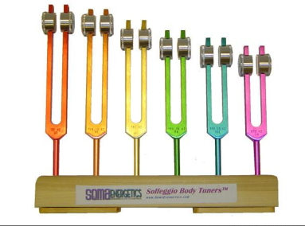
About SomaEnergetics: SomaEnergetics has been offering Vibrational Sound Tools and Training since 2000. Our mission is to offer education, instruction and training in 5th Dimensional Energy and Vibrational Sound Modalities through personal instruction kits, professional training, live CE Courses & DVD Self Study Courses. We are more than teachers, we are Awakeners ~ Awakening the world one practitioner at a time!

For More Information:
www.BackInTune.com
To Register: Call 541-221-2444
email: Backintune@ymail.com

